Unit 3 Area of Study 3 Australia and the international economy – Section B structured questions

Question 1 (8 marks)

a. Explain two gains from international trade.
4 marks
________________________________________________________________________________________________________________________________________________________________________________________________________________________________________________________________________________________________________________________________________
________________________________________________________________________________________________________________________________________________________________________________________________________________________________________________________________________________________________________________________________________
________________________________________________________________________________________________________________________________________________________________________________________________________________________________________________________________________________________________________________________________________
________________________________________________________________________________________________________________________________________________________________________________________________________________________________________________________________________________________________________________________________________

b. Identify and explain two factors that can influence Australia’s international competitiveness.
4 marks
________________________________________________________________________________________________________________________________________________________________________________________________________________________________________________________________________________________________________________________________________
________________________________________________________________________________________________________________________________________________________________________________________________________________________________________________________________________________________________________________________________________
________________________________________________________________________________________________________________________________________________________________________________________________________________________________________________________________________________________________________________________________________
________________________________________________________________________________________________________________________________________________________________________________________________________________________________________________________________________________________________________________________________________

Question 2 (7 marks)
Consider the following hypothetical data for the Australian economy.

Australia
 | XPI | MPI
2022 | 100 | 100
2023 | 98 | 102

a. Calculate the terms of trade for country X.
1 mark

b. Identify whether this was a favourable or unfavourable movement in the terms of trade, and explain one factor that could have caused this movement.
3 marks
________________________________________________________________________________________________________________________________________________________________________________________________________________________________________________________________________________________________________________________________________
________________________________________________________________________________________________________________________________________________________________________________________________________________________________________________________________________________________________________________________________________
______________________________________________________________________________________________________________________________________________________________________________________________________________________________________________________
c. Explain the effect that this movement in the terms of trade would have on one macroeconomic goal.
3 marks
________________________________________________________________________________________________________________________________________________________________________________________________________________________________________________________________________________________________________________________________________
________________________________________________________________________________________________________________________________________________________________________________________________________________________________________________________________________________________________________________________________________
________________________________________________________________________________________________________________________________________________________________________________________________________________________________________________________________________________________________________________________________________

Question 3 (4 marks)
Consider the following hypothetical data for the Australian economy.
 | $Billions
Foreign direct investment | -100
Balance of merchandise trade | 320
Net Secondary income | -40
Financial derivatives | 60
Net Other investments | 60
Net Primary income | -180
Net Reserve assets | -140
Net services | 30
Capital account | -10

a. Calculate the balance on the current account.
1 mark

b. Calculate the overall balance of payments.
1 mark

c. Explain one possible cyclical reason for the current account balance.
2 marks
________________________________________________________________________________________________________________________________________________________________________________________________________________________________________________________________________________________________________________________________________
________________________________________________________________________________________________________________________________________________________________________________________________________________________________________________________________________________________________________________________________________

Question 4 (6 marks)
$AUD against the $USD
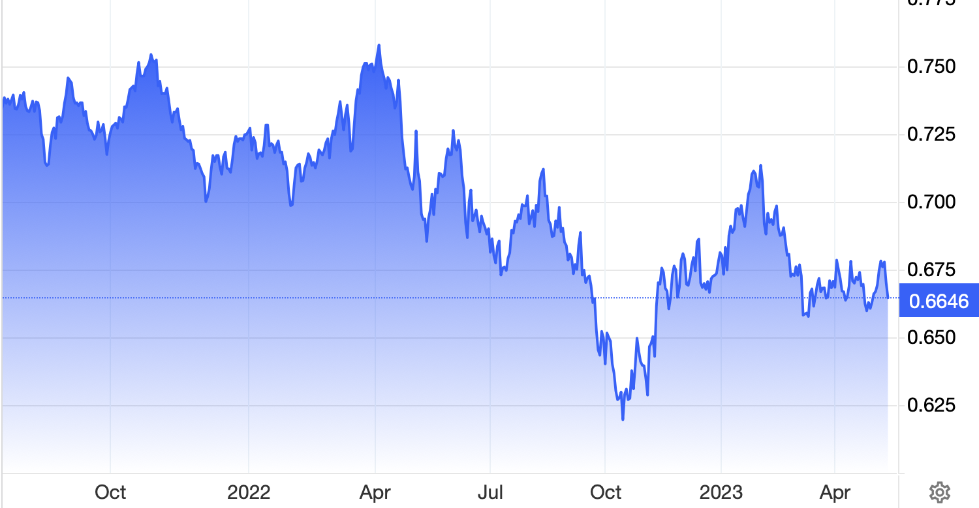

a. Referring to the data, identify and explain two possible causes for the trend in the exchange rate.
4 marks
________________________________________________________________________________________________________________________________________________________________________________________________________________________________________________________________________________________________________________________________________
________________________________________________________________________________________________________________________________________________________________________________________________________________________________________________________________________________________________________________________________________
________________________________________________________________________________________________________________________________________________________________________________________________________________________________________________________________________________________________________________________________________
______________________________________________________________________________________________________________________________________________________________________________________________________________________________________________________
b. Explain the effect that this movement in the exchange rate could have on material and non-material living standards.
2 marks
________________________________________________________________________________________________________________________________________________________________________________________________________________________________________________________________________________________________________________________________________
________________________________________________________________________________________________________________________________________________________________________________________________________________________________________________________________________________________________________________________________________
____________________________________________________________________________________________________________________________________________________________________

Extra writing space
________________________________________________________________________________________________________________________________________________________________________________________________________________________________________________________________________________________________________________________________________
________________________________________________________________________________________________________________________________________________________________________________________________________________________________________________________________________________________________________________________________________
________________________________________________________________________________________________________________________________________________________________________________________________________________________________________________________________________________________________________________________________________
________________________________________________________________________________________________________________________________________________________________________________________________________________________________________________________________________________________________________________________________________
________________________________________________________________________________________________________________________________________________________________________________________________________________________________________________________________________________________________________________________________________
________________________________________________________________________________________________________________________________________________________________________________________________________________________________________________________________________________________________________________________________________

